Position vs Time Graphs

Use the graph shown to answer each question. The first graph is for questions 1-4.

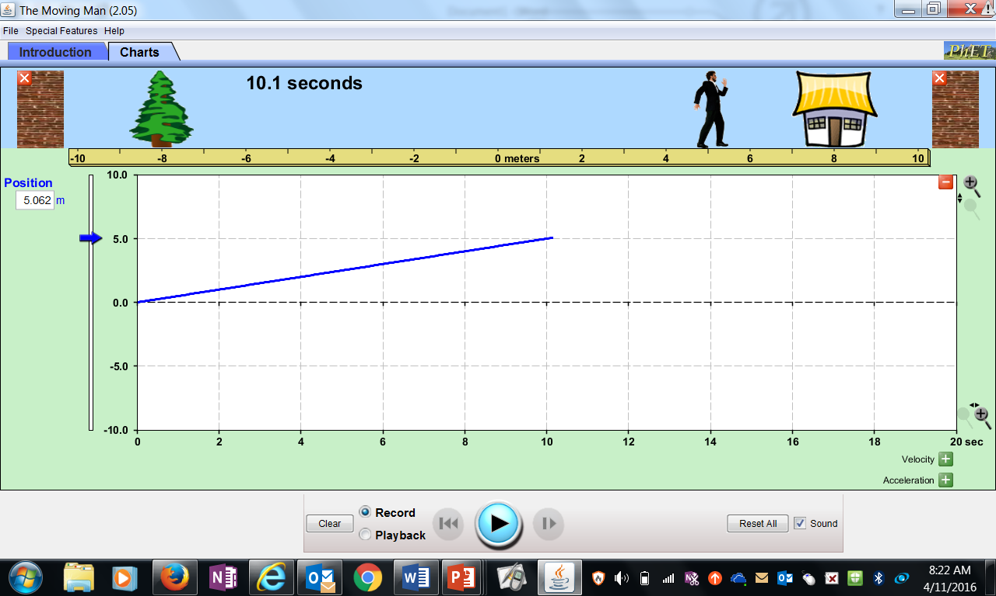

1. Determine the object’s starting (initial) position.
2. Determine the object’s position at t=10.0s
3. Determine the average velocity. Show all work!
4. Use your answer to #3 to determine the object’s position at t=5.0s Show all work, and check the graph to see if your answer makes sense.

This Graph is for #5-8

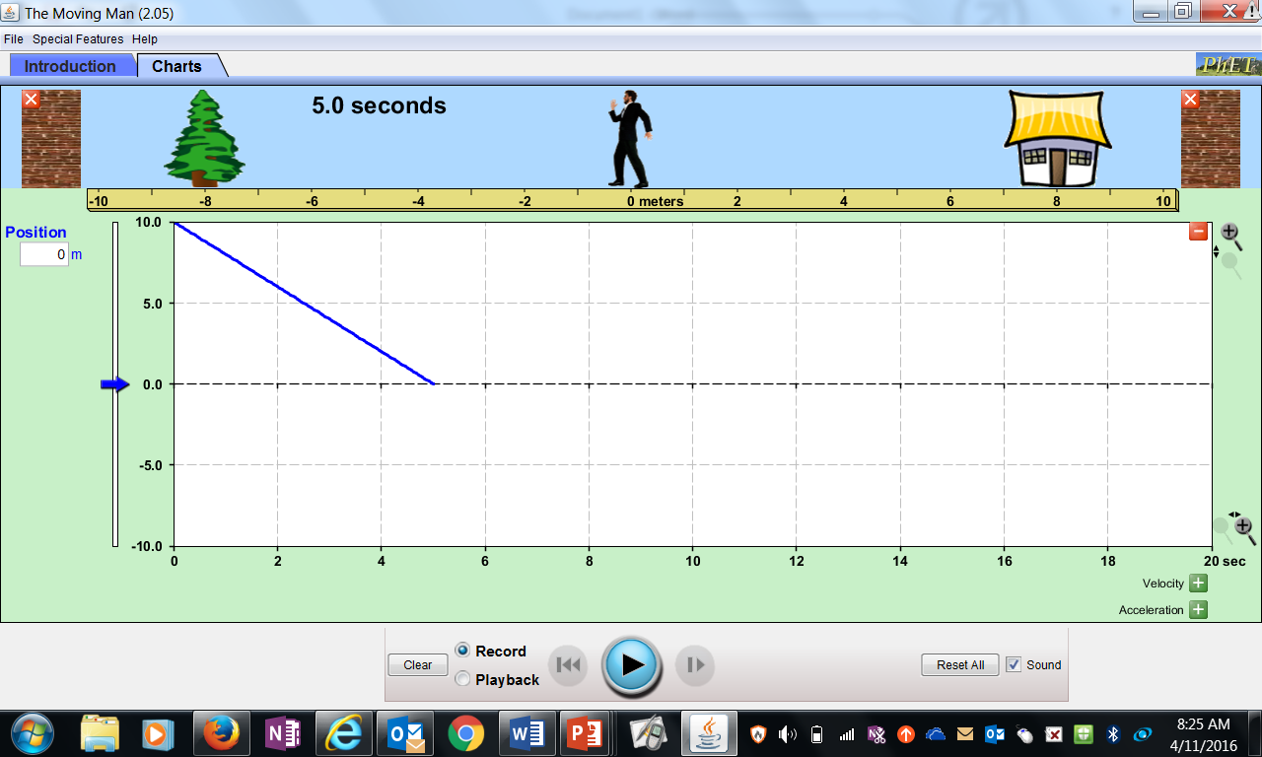

1. Determine the object’s starting (initial) position.
2. Determine the object’s position at t=5.0s
3. Determine the average velocity. Show all work!
4. Use your answer to #7 to determine the object’s position at t=2.0s Show all work, and check the graph to see if your answer makes sense.